HistGradientBoosting
36-hour demand forecasting
Prototype research report | Envitron | 27 October 2026
Prepared by Kristian & Joel • Team IT2B • NHL Stenden University of Applied Sciences
Average absolute error | Normalized MAE | Full experiment runtime
2.679 kW | 20.805% | 119.1 seconds

Executive summary
The joint HistGradientBoosting (HGB) prototype predicts electrical demand for one farm building at 15-minute intervals over a 36-hour horizon. It compares two learned variants—HGB and HGB + Weather—with Persistence and Copy-Yesterday baselines. The purpose is to assess a practical forecasting candidate for Envitron’s Energy Management System, not to operate equipment or optimize a battery directly.
On the supplied final chronological holdout, HGB + Weather achieved 2.679 kW MAE, 3.707 kW pooled RMSE and 20.805% NMAE. Its MAE was approximately 24.3% lower than Copy-Yesterday and 46.3% lower than Persistence. Adding observed origin-time weather reduced MAE by a further 2.3% relative to HGB without weather. These are results from one building and one previously inspected holdout; they do not establish universal superiority or a deployment guarantee.

Client interpretation
- Useful candidate for anticipating broad demand patterns: the learned models outperform both simple baselines in this evaluation.
- Peak prediction remains a limitation: the final-week plot shows smooth forecasts that do not reproduce many abrupt observed spikes.
- Promising development resource footprint, but not a Pi benchmark: the full experiment reported 305.75 MiB peak process RSS.
- Recommended next decision: progress to a limited prediction-only integration trial, conditional on fresh-period validation and actual Raspberry Pi/Docker measurements.

Evidence and scope
This report uses the final joint script shared during development, the final terminal results supplied by the project team, and the five charts attached for this report. No new model training was performed for the report. The final-run metrics CSV, JSON manifest, model binaries and raw input files were not independently audited. Older individual-prototype manifests are not treated as evidence for the final joint run.

1. Research purpose and prototype design

Research questions
- Can a non-linear HGB model outperform Persistence and Copy-Yesterday for the selected building under a purged chronological holdout?
- Does observed weather at the forecast origin add useful predictive information?
- What do error patterns and resource observations imply for a lightweight EMS integration?

How it works
Histogram-based gradient boosting builds an ensemble of decision trees sequentially. Each boosting stage refines the current prediction; histogram binning limits the candidate split points used in tree construction. This provides a non-linear alternative to a linear model, but does not automatically make it more accurate on every dataset.
Technical basis: scikit-learn HistGradientBoostingRegressor documentation
The implementation uses direct forecasting: one independently fitted estimator for each lead from 15 minutes to 36 hours. There are 144 estimators per variant, or 288 across both variants. Each estimator is itself a boosted-tree ensemble. Later forecast steps do not depend on earlier predicted consumption values.

Inputs and engineered features
Input group | Final implementation
Historical demand | Current reading; exact-time lags at 15 min, 1 h, 2 h, 6 h, 24 h, 48 h and 7 days.
Recent change | Current reading minus its 15-minute and one-hour lag.
Rolling context | Means over 1 h, 6 h and 24 h; standard deviations over 1 h and 24 h. Windows include the known origin reading.
Origin calendar | UTC sine/cosine time-of-day and weekday, weekend flag and month.
Target calendar | Known target-time sine/cosine time-of-day and weekday, plus month, separately for each lead.
Weather variant | Origin-time temperature, humidity, precipitation, cloud cover, shortwave/direct/diffuse radiation and wind speed.

Calendar values are known in advance; future observed consumption and weather are not used as inputs. The prototype assumes the current consumption and observed weather readings are actually available when a forecast is issued. Operational ingestion delays must be checked before deployment.

2. Data preparation and experiment controls
The selected farm building is identified by 6a1bf87e-d798-4e93-a648-a8e948fc24c2. Inputs are buildings.csv, electricity.csv and weather.csv in the script’s local data folder. The final joint implementation uses all available cleaned building history; it does not enforce a fixed 460-day crop.

Cleaning and preprocessing
- Read the source CSVs in chunks of 50,000 rows, retaining the selected building and required columns.
- Parse UTC timestamps and numeric values; remove electricity rows with invalid targets/timestamps, retain the last duplicate timestamp, and exclude negative target readings.
- Merge weather by exact building/timestamp key; construct lags and targets by exact timestamps rather than shifting across missing intervals.
- Fit median imputation and standard scaling on the training partition only, independently within each horizon pipeline. Scaling is retained for pipeline consistency, not because HGB requires it.
Negative-value removal defines the experiment’s nonnegative target cohort. The client should confirm that this exclusion matches the intended demand definition; it should not be assumed to resolve all meter semantics or all data-quality issues. Missing target readings are not imputed for scoring.

Model configuration
Setting | Value | Rationale / interpretation
Loss / learning rate | squared_error / 0.1 | Squared-error objective; fixed shrinkage.
Boosting iterations | 60 | Fixed settings retained; early stopping disabled.
Maximum leaves / bins | 15 / 63 | Limits per-tree complexity and histogram resolution.
Minimum samples per leaf | 30 | Constrains very small leaves.
L2 regularization / seed | 1.0 / 42 | Regularization and reproducible random configuration.
Thread limit | 2 | Sequential horizon fitting with a two-thread limit.

These settings were not selected by a reported exhaustive tuning study. The combined version incorporates extra historical and calendar features, but no final controlled feature-ablation experiment was supplied. Improvements cannot therefore be attributed to individual feature groups.

3. Validation protocol and metric definitions

Chronological split with target-window purging
The cutoff is selected at 90% of chronological origins with a valid 144th target. After cutoff selection, both partitions retain only origins whose complete set of 144 targets exists. Training origins are then removed whenever origin + 36 hours is greater than or equal to the test boundary. The retained training and test counts are therefore not exactly 90% and 10%.
At each successive test origin, the fitted models use observations available at that origin, including previously observed test-period history. The models are not refitted during this evaluation. This simulates repeated issuance of forecasts, not one forecast made at the beginning of the entire test period.
Technical basis: scikit-learn example on lagged features and time-ordered evaluation

Baselines and identical-pair comparison
Persistence repeats the origin’s consumption reading across all 144 leads. Copy-Yesterday uses the same daily slot one day earlier through 24-hour lead and two days earlier beyond 24-hour lead, so the reference never occurs after the origin. All four approaches are scored on the intersection of their finite origin–horizon predictions. Native availability is reported separately.

Definitions used in this report
Metric | Definition / interpretation
MAE | mean(|prediction − actual|), reported in kW. Typical absolute error size.
Pooled RMSE | sqrt(mean((prediction − actual)²)) across all common pairs, in kW. Gives greater influence to large errors.
NMAE / NRMSE | 100 × MAE / mean actual; 100 × pooled RMSE / mean actual. Mean demand uses the same common pairs.
MAPE | 100 × mean(|prediction − actual| / |actual|), excluding actuals below 100 W. Exclusion counts belong in the run metrics.
Bias | mean(prediction − actual), in kW; positive means average overprediction.
Coverage | Common coverage measures the shared scored pairs; native coverage measures each approach’s own finite predictions.

NMAE is not “100 minus accuracy.” Pooled RMSE is not the mean of horizon-specific RMSE values. Aggregate metrics include every forecast lead; they are not the error specifically at the final 36-hour lead. Multiple origin–horizon pairs can refer to the same target timestamp, so pair counts do not represent independent measurements.

4. Aggregate results: absolute errors
Table 1 reproduces the final joint-run terminal values. The comparison is internal to this prototype and uses identical prediction pairs. Values were supplied rounded to three decimal places.
Approach | MAE (kW) | Pooled RMSE (kW) | Bias (kW)
Persistence | 4.990 | 6.565 | +0.197
Copy-Yesterday | 3.539 | 5.090 | +0.094
HGB | 2.742 | 3.753 | +0.143
HGB + Weather | 2.679 | 3.707 | +0.110

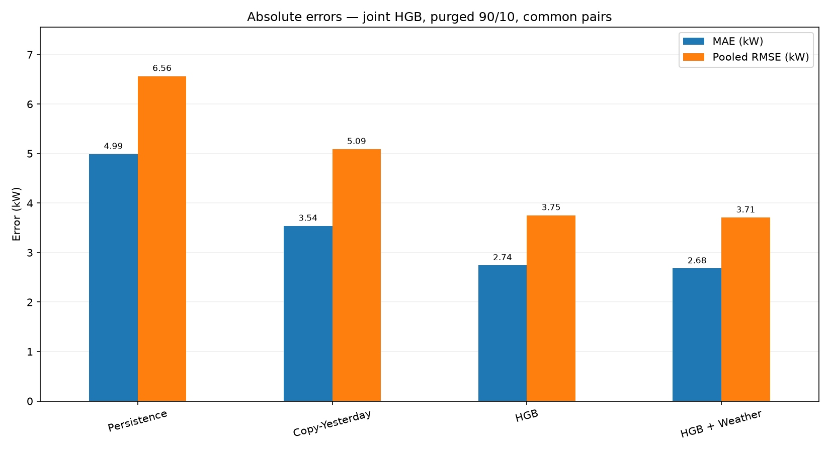
Figure 1. Absolute errors from the final supplied run. Both learned variants reduce MAE and pooled RMSE relative to the simple baselines.

Magnitude of the improvement
HGB + Weather reduces MAE by approximately 24.3% against Copy-Yesterday and 46.3% against Persistence. Against HGB alone, the reduction is 0.063 kW (about 63 W), or 2.3%. Its pooled RMSE falls by 0.046 kW, approximately 1.2%. These derived percentages use the rounded terminal values; they are descriptive comparisons, not significance tests.
The +0.110 kW mean bias is small compared with MAE, but this does not mean that individual forecasts are accurate: positive and negative errors can cancel. The reported lower errors do not quantify cost savings, battery benefits or peak-demand reduction.

5. Percentage errors and weather contribution
Approach | NMAE (%) | Pooled NRMSE (%) | MAPE (%)
Persistence | 38.749 | 50.972 | 41.805
Copy-Yesterday | 27.478 | 39.521 | 28.388
HGB | 21.295 | 29.142 | 22.848
HGB + Weather | 20.805 | 28.781 | 22.327

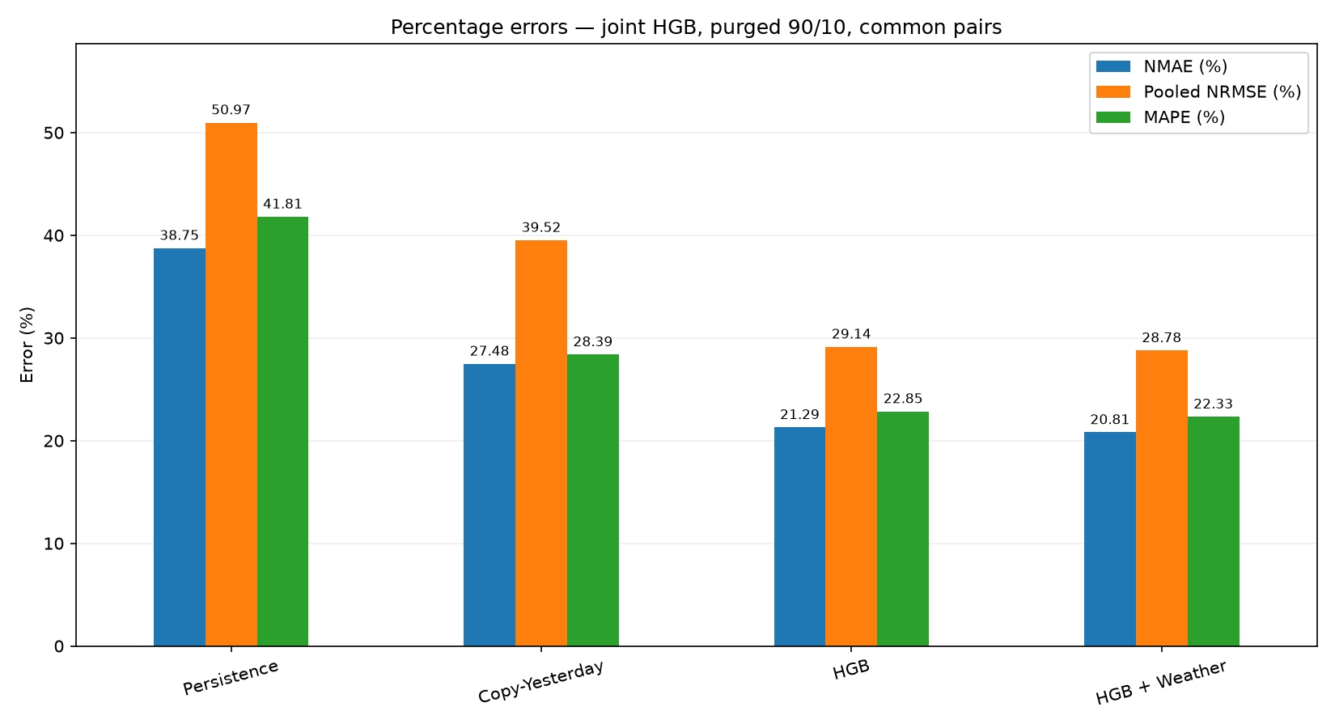
Figure 2. Percentage-error measures from the final supplied run. All denominators and exclusions follow the definitions on page 4.

Interpretation
HGB + Weather has the lowest reported aggregate MAE, pooled RMSE, NMAE, pooled NRMSE and MAPE among the four approaches in this experiment. Its 20.805% NMAE expresses absolute error relative to mean demand; its 22.327% MAPE averages individual percentage errors and therefore answers a different question.
Adding origin-time weather reduces NMAE from 21.295% to 20.805%: a 0.490 percentage-point change. This is the same approximately 2.3% relative reduction seen in MAE. Only observed origin-time weather was tested; the result does not establish the value of future weather forecasts, individual weather variables, or a causal weather effect.
The weather benefit is modest and should be rechecked on further periods before accepting its added input dependency. Statistical reliability and variation across seasons were not established. MAPE is sensitive to small actual values; the 100 W exclusion rule is part of this implementation rather than a universal metric convention.
Technical basis: scikit-learn MAPE documentation

6. Error behaviour across the forecast horizon
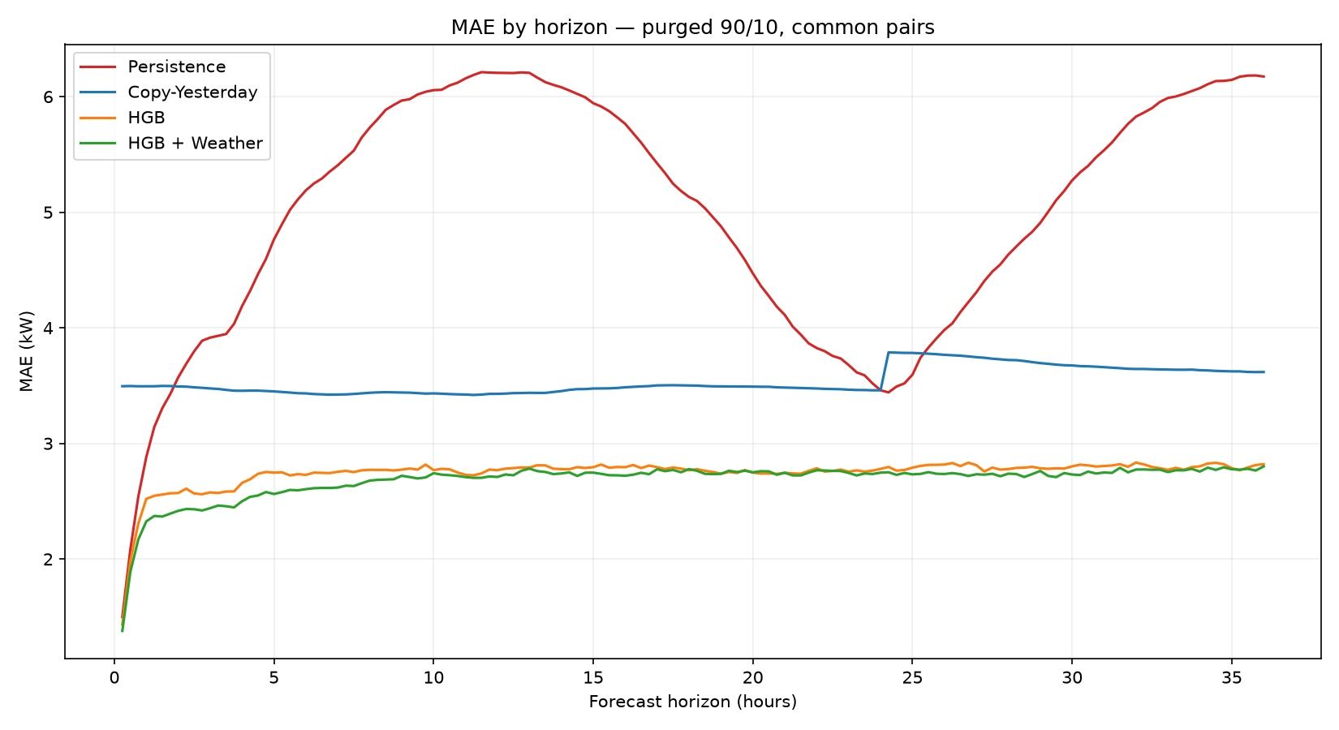
Figure 3. MAE by lead time. Qualitatively, HGB errors rise early and then remain comparatively level; weather provides a small, non-uniform difference.
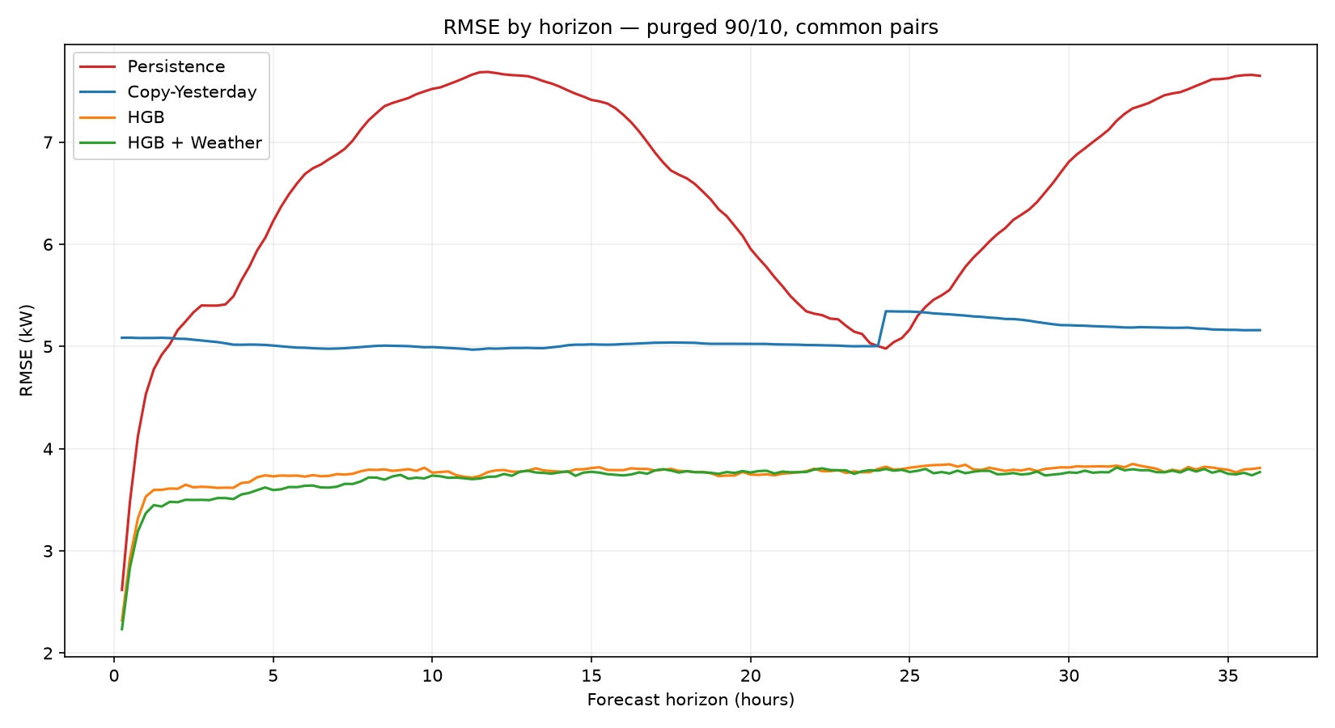
Figure 4. RMSE by lead time. The learned variants show lower errors than the baselines across the displayed leads.
Persistence has a pronounced daily-shaped error profile rather than a steady increase with lead time. Copy-Yesterday changes at the 24-hour boundary, coinciding with its defined switch from one-day to two-day references. These visual patterns are descriptive; no exact horizon-specific values are inferred from the raster charts.

7. Forecast behaviour and operational relevance
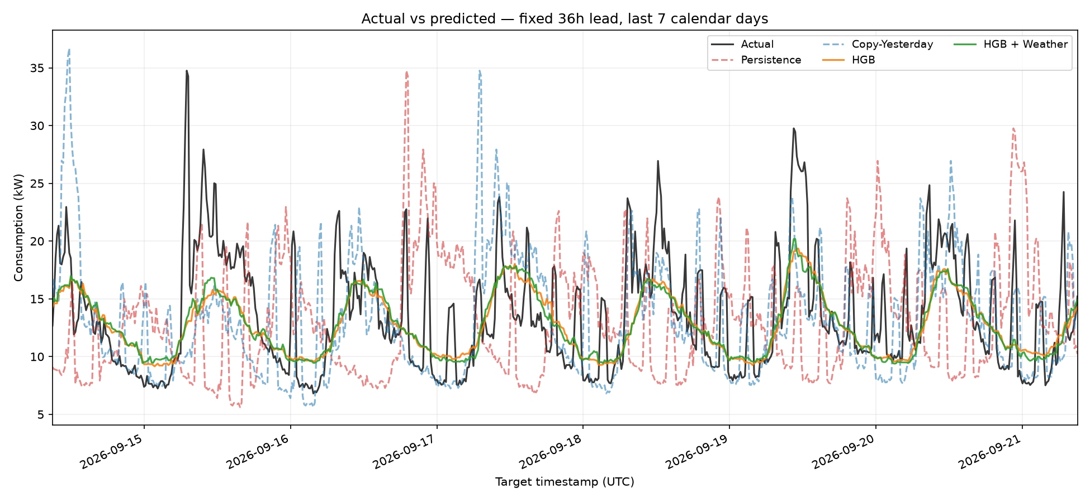
Figure 5. Actual and predicted demand at a fixed 36-hour lead over the last seven calendar days. Each prediction was issued 36 hours before its target timestamp. Gaps are not interpolated by the reporting script.

What the example shows
The HGB variants follow the broad recurring daily demand pattern but smooth many abrupt changes. Several observed peaks are not reproduced at their full magnitude, while some low-demand periods are overpredicted. The two learned curves remain close, consistent with the modest aggregate weather benefit.
The jagged baseline traces represent different forecast origins, not a contradiction of Persistence’s constant-within-one-forecast rule. For example, at a fixed 36-hour lead, successive Persistence predictions use the consumption observed at successive origins 36 hours earlier.

Meaning for Envitron
- Potential use: provide an indicative demand trajectory as an input to EMS planning and scenario evaluation.
- Current limitation: avoid relying on these point forecasts alone for high-consequence peak control, reserve sizing or automated battery commitments.
- Evidence boundary: the selected seven-day view illustrates behaviour; aggregate metrics cover the complete retained holdout, not only this figure.
- Next investigation: quantify errors during high-demand events and compare operational consequences with simple-baseline forecasts.
No equipment schedules or operational-event features were supplied. Missing drivers are a possible explanation for unpredictable spikes, not an established diagnosis. The current model produces point forecasts; no calibrated uncertainty intervals were delivered.

8. Verification status and resource observations
Testing evidence is separated from implementation safeguards. “Implemented” below means visible in the final shared script; it does not imply an independently reproduced test run.
Check / test | Available evidence | Status
Chronological holdout and baseline comparison | Final terminal results and five supplied charts. | Completed run reported by team.
Target-window isolation | Final script rejects a latest training target at or beyond test start. | Runtime safeguard implemented.
Cohort completeness / common masks | Complete-target filtering, shared finite mask and equal per-horizon count check. | Implemented; final mask not independently re-audited.
Baseline timing / HGB output validity | Future-reference assertion; finite-prediction check. | Runtime safeguards implemented.
Causal features / model reload equivalence | Related combined development package previously passed 12 synthetic checks. | Not a test certificate for this exact final single-file version.
Final model save/reload regression | Save operations are present; final binary reload logs not supplied. | Requires final-version verification.
Multi-period, multi-building and Pi/Docker tests | No corresponding final logs supplied. | Not demonstrated.

Measured resource observations
Observation | Reported value | Scope
Wall-clock runtime | 119.1 seconds | Complete script: loading, training both variants, evaluation, saves and charts.
Peak process RSS | 305.75 MiB | Python-process high-water mark on the reported development run.
Parallelism setting | 2 threads | Configured limit; horizons fitted sequentially.

These observations are not per-forecast latency, model-only RAM, total container memory or a Raspberry Pi benchmark. Hardware specifications and the final environment manifest were not supplied for independent comparison. Runtime and memory should not be compared directly with another prototype unless workload scope, hardware, versions and units match.

9. Conclusions, next decisions and handover

Conclusion
The joint HGB prototype is a credible research candidate for building-level demand forecasting. It substantially outperformed the two simple baselines on the supplied holdout and achieved its lowest aggregate error with origin-time weather. The evidence supports further controlled integration work, not an unconditional production release or a claim of proven superiority over the other subteams.

Priority actions for the client and project team
- Agree acceptance criteria: name the primary error metric and denominator, critical forecast leads, peak-error tolerance, latency, RAM budget and operational fallback requirements.
- Validate a frozen configuration on fresh chronological periods and further buildings. Preserve a genuinely untouched final test period; avoid selecting models repeatedly against this already inspected holdout.
- Create a prediction-only entry point using the same feature construction and fitted pipelines. Define stale-input checks, missing-weather handling and clearly labelled fallback forecasts.
- Benchmark actual model loading, feature construction, 144-step inference and sustained container memory on the intended Raspberry Pi. Repeated forecasts must not trigger full retraining or chart generation.
- Align all subteams’ data cohorts, purge rules, scored pairs and normalization before publishing a model ranking. The earlier Ridge implementation differed in boundary handling/aggregation; another subteam used range-based rather than mean-demand normalization.

Delivered prototype artifacts and reproducibility
The script produces five PNG charts plus metrics_90_10.csv and run_summary.json under output/hgb_36h_joint/, and hgb_90_10.joblib plus hgb_weather_90_10.joblib under models/hgb_36h_joint/. Each bundle contains 144 fitted preprocessing/HGB pipelines and feature metadata. Live input engineering and timestamp scheduling remain integration responsibilities.
For handover, attach the exact final script/commit, immutable input-data identification, final run-summary JSON, metrics CSV, model checksums and a locked dependency environment. Load joblib artifacts only from trusted sources and use matching package versions. Cross-version scikit-learn loading is unsupported.
Technical basis: scikit-learn model persistence and deployment guidance
Final-run evidence used here: five charts supplied on 27 October 2026 and the previously supplied terminal table (119.1 s; 305.75 MiB). Exact cohort dates/counts, final run ID and final dependency versions are deliberately not copied from older individual-run manifests. Quantitative claims should be checked against the final machine-readable artifacts before external sign-off.

